Distribution of Igneous Rocks
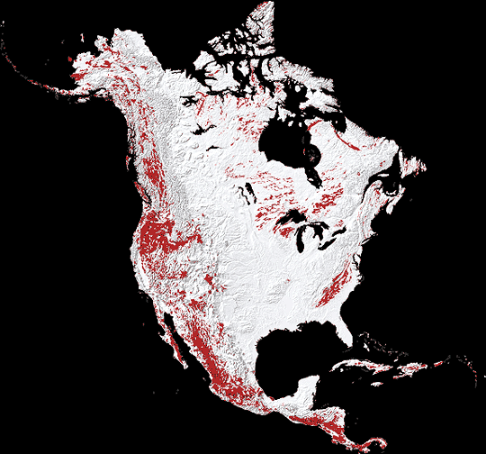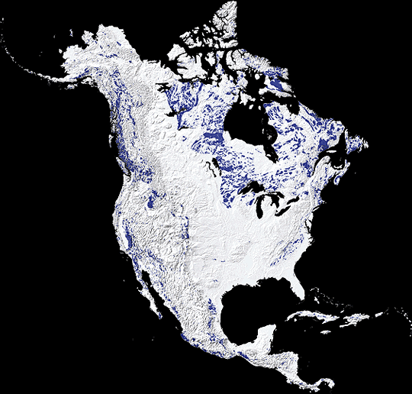

IGNEOUS ROCKS- extrusive IGENOUS ROCK- intrusive
Extrusive- Igneous rocks are formed from magma that cools at the earth's surface or in the upper regions of the crust. The magma that reaches the surface, called lava, is exposed to much cooler water or air; and because it forms outside of the crust, it is called extrusive rock. It hardens quickly, sometimes within minutes or hours. Since magma typically reaches the surface through volcanoes, this extrusive rock is commonly labeled volcanic. A good example of this is obsidian, a dark rock used by some ancient cultures to make stone cutting tools. Other common or well-known volcanic rocks include basalt, rhyolite, and pumice.
Intrusive- Those igneous rocks that cool within the crust are called intrusive rocks. They form from magma that flows into the upper crust, and hardens very slowly, over many years. They are often found in the bases of old volcanoes or mountain ranges formed by volcanic activity, the rock resulting from magma that did not erupt. For example, granite, a well-known intrusive rock, usually has evident grains of quartz, biotite and feldspar in it.
Where are igneous rocks found, what type of landforms are they most commonly found by? __________________________________________________________________________________________________________________________________________________________________________

 | Extrusive | Intrusive
How does it form?
Where does it form?
How fast does it form?
Examples

