Activity:
For each of the energy transfers fill in the spaces using the words in the box.
A clockwork car

Movement stored

Energy stored in my body energy..................... in the ..................energy of the
Wound-up spring clockwork car.

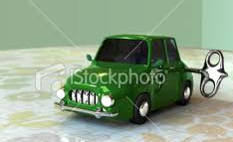
A battery and a lamp bulb
Heat stored light electrical
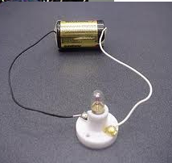
.............. energy of the bulb
Energy ............... in the ........................energy
battery. .............. energy warming up
bulb.

A battery and a buzzer
Sound stored energy electrical

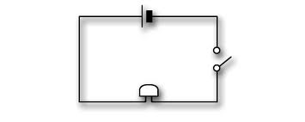
................ ............... in the ........................energy ...................... energy of the
battery. buzzer.

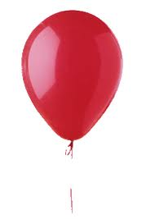A blown up balloon and then released.

Stretched body movement stored

Energy stored
In my ................ energy .............. in the ............... .........................energy
balloon of the balloon

A Bunsen burner
light heat gas stored

.............. energy lighting up the room.
Energy ............... in the ............
.............. energy of the flame



