Name: ____________________

Environmental viewpoints
Directions:
1. Name if the pictures are development, conservation or preservation
2. Explain why

1. __________________________________________
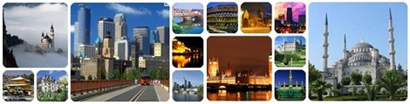
Explanation: _______________________________________________________________________________________________________________________________________________________________________________________________________________________________________________________________

2. ___________________________________________
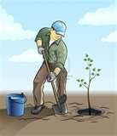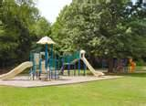
Explanation: _______________________________________________________________________________________________________________________________________________________________________________________________________________________________________________________________

3. ____________________________________________

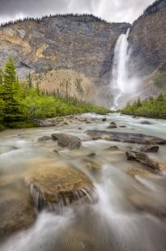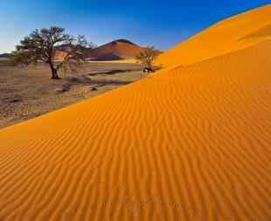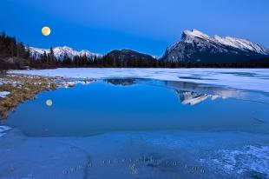
Explanation: _______________________________________________________________________________________________________________________________________________________________________________________________________________________________________________________________
City wide battle of what to do with an area of forest
A city in Michigan is having an environmental debate. There is an area of wooded trees (forest) right by a new exit ramp off of the I-94 freeway. Three different groups have opinions on how the land should be used. You need to pretend you are the spokesperson for each group. Write down in the table below what your groups plan would be for the forested land and why.
Development | Conservation | Preservation

