NAME: ____________________________________

HOW FOSSILS FORM
Fossils of hard mineral parts (like bones and teeth) were formed as follows:
- Some animals were quickly buried after their death (by sinking in mud, being buried in a sand storm, etc.).
- Over time, more and more sediment covered the remains.
- The parts of the animals that didn't rot (usually the harder parts likes bones and teeth) were encased in the newly-formed sediment.
- In the right circumstances (no scavengers, quick burial, not much weathering), parts of the animal turned into fossils over time.
- After a long time, the chemicals in the buried animals' bodies underwent a series of changes. As the bone slowly decayed, water infused with minerals seeped into the bone and replaced the chemicals in the bone with rock-like minerals. The process of fossilization involves the dissolving and replacement of the original minerals in the object with other minerals (and/orpermineralization, the filling up of spaces in fossils with minerals, and/or recrystallization in which a mineral crystal changes its form).
- This process results in a heavy, rock-like copy of the original object - a fossil. The fossil has the same shape as the original object, but is chemically more like a rock! Some of the original hydroxy-apatite (a major bone consitiuent) remains, although it is saturated with silica (rock).
Here's a flow chart of fossil formation:
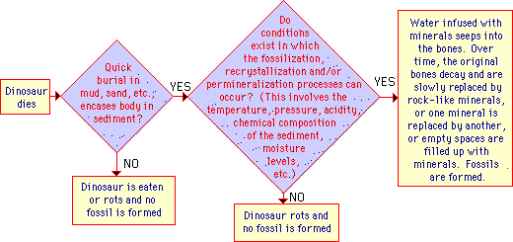 Most animals did not fossilize; they simply decayed and were lost from the fossil record. Paleontologists estimate that only a small percentage of the dinosaur genera that ever lived have been or will be found as fossils.
Most of the dinosaur skeletons that are shown in museums are not actually fossils! Exhibits are often lightweight fiberglass or resin replicas of the original fossils.
Why are Fossils Rock-Colored?
Because they ARE rocks! A fossilized object is just a rocky model of an ancient object. A fossil is composed of different materials than the original object was. During the fossilization process, the original atoms are replaced by new minerals, so a fossil doesn't have the same color (or chemical composition) as the original object. Fossils come in many colors and are made of many different types of minerals, depending on what the surrounding rock matrix was composed of; one dinosaur bone (Minmi) is an opal.
Also, some fossils of skin (and other soft body parts) have been found. Again, the color of the skin is not retained during the fossilization process, all that remains today is a rocky model of the original.
Task:
Create 3 test questions and write the answers for them. Mrs. Matzka will pick 15 of the best questions to be part of a future assignment.
Question 1 : ____________________________________________________________________________________________________________________________________________________________
Answer 1: ____________________________________________________________________________________________________________________________________________________________
Question2 : ____________________________________________________________________________________________________________________________________________________________
Answer 2: ____________________________________________________________________________________________________________________________________________________________
Question 3 : ____________________________________________________________________________________________________________________________________________________________
Answer 3: ____________________________________________________________________________________________________________________________________________________________

