In my OWN words this means . . . | TEXT  Chapter 29 Section 1: Structure of the Sun | Write or draw what you visualize while reading the text.
 | 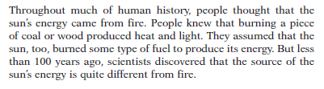
 | 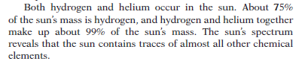
 | 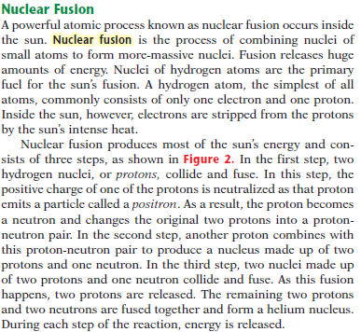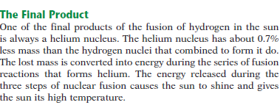
 | 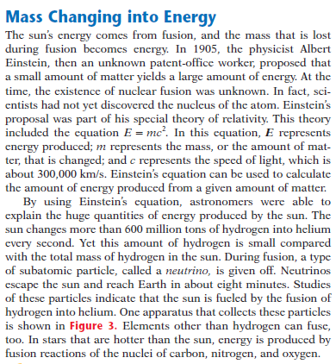
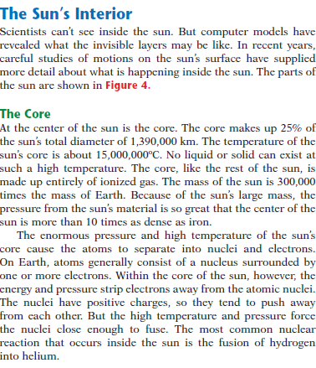
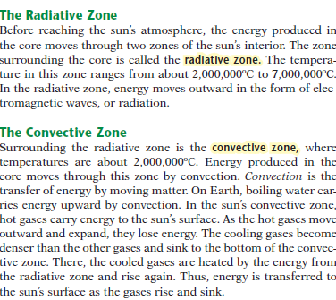
 | 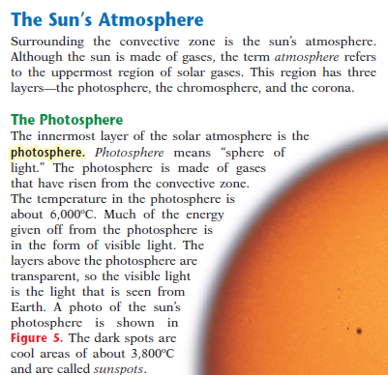
 | 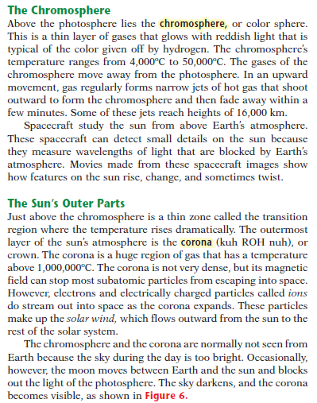.

Key Concepts
- The enormous pressure and heat in the sun’s core converts matter into energy through the process of _________________________________________.
- Nuclear fusion combines four hydrogen nuclei to form one ________________ nucleus.
- Energy from the sun’s _________________ moves through the radiative zone and the convective zone before it enters the sun’s atmosphere.
- The sun’s atmosphere is composed of the photosphere, the chromosphere, and the _______________________.
- _________________________________________ forms when electrons and electrically charged particles called ions from the corona travel out into space.

