- January 21, 2013 Vol. 79 No. 2

Maria Belon: The Impossible's Real-Life Survivor
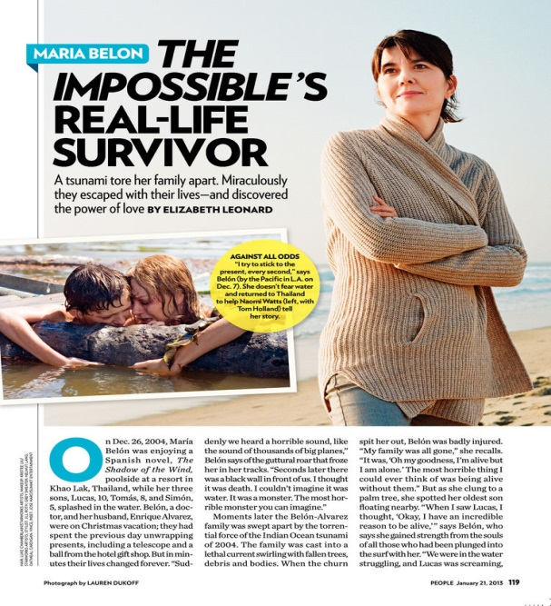
By ELIZABETH LEONARD

A Tsunami Tore Her Family Apart. Miraculously They Escaped with Their Lives-and Discovered the Power of Love
http://www.people.com/people/archive/article/0,,20666183,00.html
On Dec. 26, 2004, Maria Belon was enjoying a Spanish novel, The Shadow of the Wind, poolside at a resort in Khao Lak, Thailand, while her three sons, Lucas, 10, Tomas, 8, and Simon, 5, splashed in the water. Belon, a doctor, and her husband, Enrique Alvarez, were on Christmas vacation; they had spent the previous day unwrapping presents, including a telescope and a ball from the hotel gift shop. But in minutes their lives changed forever. "Suddenly we heard a horrible sound, like the sound of thousands of big planes," Belon says of the guttural roar that froze her in her tracks. "Seconds later there was a black wall in front of us. I thought it was death. I couldn't imagine it was water. It was a monster. The most horrible monster you can imagine."
Moments later the Belon-Alvarez family was swept apart by the torrential force of the Indian Ocean tsunami of 2004. The family was cast into a lethal current swirling with fallen trees, debris and bodies. When the churn spit her out, Belon was badly injured. "My family was all gone," she recalls. "It was, 'Oh my goodness, I'm alive but I am alone.' The most horrible thing I could ever think of was being alive without them." But as she clung to a palm tree, she spotted her oldest son floating nearby. "When I saw Lucas, I thought, 'Okay, I have an incredible reason to be alive,'" says Belon, who says she gained strength from the souls of all those who had been plunged into the surf with her. "We were in the water struggling, and Lucas was screaming, 'We're going to die!' I could feel something incredible, and I said, 'We need to be courageous, we need to take care of each other, but we will not die.' Lucas was 10 years old, but he was very brave."
Her journey-now depicted in The Impossible, a film that's garnering awards buzz, including a Golden Globe nomination for star Naomi Watts-is a tale of survival against all odds. The tsunami took 230,000 lives in 14 countries, but somehow spared Belon's entire family, who found each other at a hospital after days of frantic searching. Still, Belon insists nothing special spared her life. "There is no difference between me-a Spanish woman named Maria who is alive-and thousands of moms who are under the sea. I do not deserve to be alive, but life is not fair. I feel pain and compassion for so many others who didn't come back up or lost the ones they love."
And even in the darkest moments, Belon experienced moments of light. "Lucas and I were hugging in this tree, mostly in silence, but from time to time, he would say, 'I'm happy, Mommy, that you are with me,' and I said, 'I'm happy I'm with you, Lucas.' It was one of the most beautiful moments in my life," she says. She also honors the local Thai population, who suffered enormous tragedy but helped her and many others. Belon is particularly thankful to a villager who kept her conscious during the ride to a hospital after she and Lucas were rescued by locals. "The man kept slapping me every time I started to die, saying, 'Look at your son!' He knew I was letting myself go."
Belon spent four months in a Singapore hospital, where she battled infections and underwent 16 surgeries. Emotional healing took longer. The family slept with the lights on for six months; her youngest, Simon, had nightmares about monsters missing eyes. "When my husband found Simon, he [was near] two corpses-one without an eye," says Belon. To help her son, she used a "magic" toy frog to "eat" his nightmares. "Every morning we drew his nightmares and put them in the frog's mouth. And every day I would [secretly] tear off a tiny bit of the paper." Gradually the bad dreams were made to disappear. "Some drawings were in there for a long time."
It took a year for the family to return to the sea. But now they gather at a beach every Dec. 26. "It is our family's birthday-our Thanksgiving," says Belon, who lives in Madrid with Alvarez and Simon, now 13 (Lucas, 18, is studying medicine in London, and Tomas, 17, is in high school in Wales). "No matter where we all are, this is a commitment we have forever. We need to be close to the souls [of the dead]."
The water holds no terror for Belon now. Wherever she goes, she says she takes all those affected by the tsunami's power with her. Running a finger near a scar on her arm, she says, "My scars will be with me forever. My whole story is on my body. And it is wonderful because it means I am alive."

